**CHEMISTRY**

**UNIT 1**

**2015**

***Name: ________________________________________________***

**Structure of this paper**

|  |  |  |  |  |  |
| --- | --- | --- | --- | --- | --- |
| Section | Number of questions available | Number of questions to be answered | Suggested working time  (minutes) | Marks available |  |
| Section One:  Multiple-choice | 25 | 25 | 40 | /25 |  |
| Section Two:  Short answer | 12 | 12 | 60 | /60 |  |
| Section Three:  Extended answer | 5 | 5 | 50 | /45 |  |
|  |  |  |  | /130 | /100 |

1. Which element does not form ions with the same electron configuration as Argon?

(a) S

(b) Ca

(c) Al

(d) Cl

2. Using the given coefficients, balance the unbalanced equation below:

...Na3P04 (aq) + ...CaCl2 (aq) 🡪....NaCl(aq) + ...Ca3(PO4)2(s)

(a) 1,3,3,1

(b) 2,3,3,2

(c) 2,3,6,1

(d) 2,3,3,1

3. A metal (X) ion combines with the oxide ion to form an ionic compound with the formula X2O3. Which of the following is the most likely formula when X combines with the nitride ion?

(a) X2N3

(b) XN

(c) X3N2

(d) XN3

4. Which of the following compounds has a bonding structure which differs from the other three?

(a) Na2SO4

(b) RbOH

(c) NH4Cl

(d) SiO2

5. In which of the following molecules would you find six electrons shared between two bonding atoms?

(a) oxygen gas O2

(b) ethane gas C2H6

(c) ammonia gas NH3

(d) nitrogen gas N2

6. In an experiment a student weighs 4.700 g of a substance whose molar mass is 27.2 g mol-1.

Which of the following correctly reports the moles of the substance?

(a) 1.7 x 10-1 mol

(b) 1.72 x 10-1 mol

(c) 1.73 x 10-1 mol

(d) 1.728 x 10-1 mol

7. Which of the following statements is the best definition of ionisation energy?

(a) It is the energy needed to change a mole of a substance from a liquid to a gas.

(b) It is the energy required to dissociate one mole of ions in the solid phase.

(c) It is the energy required to remove a mole of electrons from a mole of

atoms or ions of an element in the gaseous phase.

1. It is the energy required to form one mole of an ionic substance from its

constituent atoms.

8. Which one of the following substances can conduct electricity?

(a) NaF (s)

(b) NH4Cl (s)

(c) HCl (g)

(d) C (s) (graphite)

9. Mass spectrometers separate isotopes of different elements based on their:

1. Mass only
2. electric charge only
3. mass and electric charge
4. emission of photons

10. Sulfuric acid is manufactured by the Contact process which involves the following series of

reactions.

S (s) + O2 (g) 🠢 SO2 (g)

2SO2 (g) + O2 (g) ⮀ 2SO3 (g)

SO3 (g) + H2O (l) 🠢 H2SO4 (l)

How many **moles of sulfur**, S, are needed to produce 3.0 mole of sulfuric acid?

(a) 2

(b) 3

(c) 6

(d) 9

11. Silicon dioxide has a much higher melting point than carbon dioxide. Which of the following best explains this difference?

(a) Silicon dioxide is a larger molecule than carbon dioxide, so the forces between its molecules are greater than those between carbon dioxide molecules.

(b) Carbon is a more electronegative atom than silicon, so it attracts oxygen

atoms with a stronger force than silicon can.

(c) The double bonds within silicon dioxide molecules are stronger than the

double bonds within carbon dioxide molecules.

(d) Silicon atoms form extended single covalent bonding in silicon dioxide,

so its structure is a network solid whereas carbon dioxide forms discrete molecules with intermolecular forces between the molecules.

12.The percentage by mass of carbon is 82.7% in

1. methane CH4
2. ethane C2H6
3. propane C3H8
4. butane C4H10

13.Which of the following is always produced during combustion of fossil fuels?

1. Water
2. Carbon (soot)
3. Sulfur dioxide
4. Carbon monoxide

14. “Line spectra” are caused primarily by:

(a) The existence of multiple ground states in an atom

(b) The release of multiple photons from an atom

(c) The existence of multiple atoms in a typical sample

(d) The existence of multiple excited states in an atom

15.Which of the following ions could be easily distinguished from the others using a flame test?

1. Al3+
2. Cu2+
3. Mg2+
4. Zn2+

16. A student performed a sampling technique as part of an investigation and repeated the sampling technique several times. What aspect of the experiment was improved by repeating the procedure?

1. Accuracy
2. Reliability
3. Safety
4. Validity

17.Iodine readily sublimes from solid to gas following moderate heating. The nature of the particles in these two physical states of iodine can be best described as?

***Solid🡪 vapour***

(a) ionic🡪 atomic

(b)ionic🡪 molecular

(c) molecular🡪 atomic

(d) molecular🡪 molecular

18. Which one of the following substances conducts electricity by the *movement of oppositely charged ions*?

(a) aluminium metal

(b) carbon

(c) solid zinc chloride

(d) molten sodium chloride

19. Which of the following statements about graphite is correct?

1. Graphite has a melting point similar to diamond.
2. Graphite is very hard. This is due to the need to break very strong carbon-carbon bonds operating in 3-dimensions.
3. Graphite doesn't conduct electricity. All the electrons are held tightly between the atoms, and aren't free to move.
4. Graphite is insoluble in water and organic solvents.

20. Propane is commonly used as a fuel for portable stoves. It combusts with oxygen to produce carbon dioxide and water. The reaction is commonly represented as:

C3H8(g) + 5O2(g) 🡪 3CO2(g) + 4H2O(g)

Which of the following alternative does not accurately represent a correct mole relationship for the above reaction?

1. n(CO2) = 3/5 x n(O2)
2. n(H2O) = 4/5 x n(O2)
3. n(CO2) = 5/3 x n(O2)
4. n(H2O) = 4/3 x n(CO2)

21. Which of the following does **not** change during any chemical reaction?

(a) total number of molecules in the system

(b) total volume of the system

(c) total mass of the system

(d) temperature of the system

22. How many **atoms** are there in K4[Fe(CN)6]3 ?

(a) 7

(b) 25

(c) 43

(d) 6.022 x 1023

23. Which of the following is **true** for two moles of ammonium nitrate, NH4NO3? There will be:

(a) 4 moles of hydrogen atoms

(b) 6 moles of nitrate ions

(c) 4 moles of nitrogen atoms

(d) 4 moles of ammonium ions

QUESTIONS 24 and 25 ARE BASED ON THE FOLLOWING PART OF THE PERIODIC TABLE

The symbols for the elements are fictitious.

|  |  |  |  |  |  |  |  |  |  |  |  |  |  |  |  |  |  |
| --- | --- | --- | --- | --- | --- | --- | --- | --- | --- | --- | --- | --- | --- | --- | --- | --- | --- |
|  |  |  |  |  |  |  |  |  |  |  |  |  |  |  |  |  |  |
| P |  |  |  |  |  |  |  |  |  |  |  | V | U |  |  | Y |  |
| S | R |  |  |  |  |  |  |  |  |  |  |  |  |  | X |  |  |
|  | Q |  |  |  |  |  |  |  |  |  |  | W |  |  |  |  |  |

24. Which of the element(s) from the above periodic table would have three valence electrons?

(a) V only

(b) S, R and X only

(c) V and W only

(d) X only

25. The chemical properties of an element R are most like those of element:

(a) S

(b) Q

(c) S and X

(d) S and Q

END OF SECTION ONE

26. Isotopes of carbon are used to determine the age of fossilised organic samples dug up by archaeologists.

1. Explain what is meant by the term isotope. (2 marks)

_____________________________________________________________________________________________________________________________________________________________________________________________________________________________________________

1. Explain why isotopes of the same element have the same chemical properties.

(2 marks)

____________________________________________________________________________________________________________________________________________________________________________________________________________________________________________________________________________________________________________________________

1. Calculate the mass, in grams, of a single atom of the isotope carbon-12.

(2 marks)

__________________________________________________________________________________________________________________________________________________________________________________________________________________________________________________________________________________________________________________________________________________________________________________________________________________________________________________________________________________________

27. Draw electron-dot diagrams showing the arrangement of valence electrons in the following chemical species. (5 marks)

Represent all valence shell electron pairs either as : or –

|  |  |
| --- | --- |
| Ethane C2H6 | Hydroxide ion OH- |
|  |  |

28. (a) Using labelled arrows, on the periodic table below clearly label the trends in electronegativity, first ionisation energy and atomic radius. (3 marks)

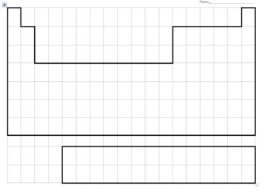

(b) Describe and explain the trends for atomic radius. (4 marks)

____________________________________________________________________________________________________________________________________________________________________________________________________________________________________________________________________________________________________________________________________________________________________________________________________________________________________________________________________________________________________________________________________________________________________________________________________________________________________________________________________________________________________________________________________________________________________________________________________________________________________________________________________________________________________________________________________________________________________________________

29. Complete the following table (4 marks)

|  |  |  |
| --- | --- | --- |
| **SUBSTANCE** | **NAME** | **TYPE(s) of BONDING** |
| Ti |  |  |
| CS2 |  |  |
| NH3 |  |  |
| NH4Cl |  |  |

30. Explain, with the aid of a diagram, how movement of electrons within an atom produces the

emission spectra responsible for observations in flame tests. (4 marks)

|  |
| --- |
| Diagram |

_______________________________________________________________________________________________________________________________________________________________________________________________________________________________________________________________________________________________________________________________________________________________________________________________________________________________________________________________________________________________________________________________

31. A sample of gaseous vanadium is analysed by mass spectrometry. The vanadium atoms are first ionised then accelerated before being deflected. (2,1,1 marks)

(a) Describe briefly how positive ions are formed from gaseous vanadium atoms in a mass

spectrometer.

_____________________________________________________________________________________________________________________________________________________________________________________________________________________________________________

(b) What is used in a mass spectrometer to accelerate the positive ions?

______________________________________________________________________________________________________________________________________________________________

(c) What is used in a mass spectrometer to deflect the positive ions?

______________________________________________________________________________________________________________________________________________________________

32. Describe the differences in malleability and electrical conductivity for metals and ionic

compounds. Explain these properties by referring to the bonding involved. (6 marks)

_______________________________________________________________________________________________________________________________________________________________________________________________________________________________________________________________________________________________________________________________________________________________________________________________________________________________________________________________________________________________________________________________________________________________________________________________________________________________________________________________________________________________________________________________________________________________________________________________________________________________________________________________________________________________________________________________________________________________________________________________________________________________________________________________________________________________________________________________________________________________________________________________________________________________________________________________________________________________________________________________________________________________________________________________________________________________________________________________________________________________________________________________________________________________________________________________________________________________________________________________________________________________________________________________________________________________________________________________________________________________________________________________________________________________________________________________________________________________________________________________________________________________________________________

33. Compare the properties of hardness, melting point and electrical conductivity for a covalent molecular substance like water, and a covalent network substance like diamond. Explain the properties by referring to the bonding involved.

(6 marks)

________________________________________________________________________________________________________________________________________________________________________________________________________________________________________________________________________________________________________________________________________________________________________________________________________________________________________________________________________________________________________________________________________________________________________________________________________________________________________________________________________________________________________________________________________________________________________________________________________________________________________________________________________________________________________________________________________________________________________________________________________________________________________________________________________________________________________________________________________________________________________________________________________________________________________________________________________________________________________________________________________________________________________________________________________________________________________________________________________________________________________________________________________________________________________________________________________________________________________________________________________________________________________________________________________________________________________________________________________________________________________________________________________________________________________________________________________________________________________

34. Diagram representing fractional distillation of crude oil.

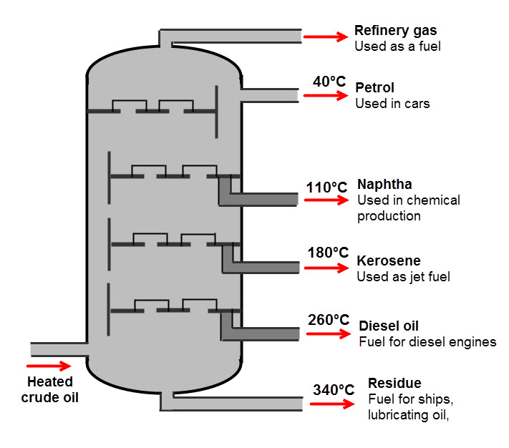

a) Give a brief description demonstrating your understanding of what is occurring in the diagram.

(3 marks)

___________________________________________________________________________________________________________________________________________________________________________________________________________________________________________________________________________________________________________________________________________________________________________________________________________

b) Name the physical property that the process depends upon (1 mark)

_______________________________________________________________________________

c) Write an equation for the complete combustion of the alkane C8H18  (2 marks)

______________________________________________________________________________________________________________________________________________________________

35. Magnesium sulphate crystals have the formula MgSO4.7H2O . What loss of mass occurs when

the water of crystallization is completely removed from 2.46 g of the crystals by gentle heating.

(4 marks)

__________________________________________________________________________________________________________________________________________________________________________________________________________________________________________________________________________________________________________________________________________________________________________________________________________________________________________________________________________________________

36. Write a balanced equation for the following reactions.

1. Sodium carbonate solid with dilute sulphuric acid (4 marks)

_____________________________________________________________________________________________________________________________________________________________________________________________________________________________________________

1. Barium hydroxide solution mixed with zinc nitrate solution.

_____________________________________________________________________________________________________________________________________________________________________________________________________________________________________________

37. Write **observations** for any reactions that occur in the following procedures. In each case

describe in full what you would observe: (4 marks)

1. Lead nitrate solution added to potassium iodide solution.

_____________________________________________________________________________________________________________________________________________________________________________________________________________________________________________

1. An iron nail is dropped into dilute nitric acid.

_____________________________________________________________________________________________________________________________________________________________________________________________________________________________________________

END OF SECTION TWO

**Section Three: Extended answer 35% (45 marks)**

This section contains five (5) questions. You must answer all questions. Write your answers in the spaces provided below.

Where questions require an explanation and/or description, marks are awarded for the relevant chemical content and also for coherence and clarity of expression. Lists or dot points are unlikely to gain full marks.

Final answers to calculations should be expressed to the appropriate significant figures.

Spare pages are included at the end of this booklet. They can be used for planning your responses and/or as additional space if required to continue an answer.

* Planning: If you use the spare pages for planning, indicate this clearly at the top of the page.
* Continuing an answer: If you need to use the space to continue an answer, indicate in the original answer space where the answer is continued, i.e. give the page number. Fill in the number of the question(s) that you are continuing to answer at the top of the page.

Suggested working time: 50 minutes.

**Question 38. (6 marks)**

The annual contribution of Western Australia's mineral and petroleum industry to the Australian economy is well over $100 billion dollars. The industry employs approximately 100,000 people. Drug testing is an important process where Chemists are employed to ensure that the workplace remains safe. All employees are subjected to a stringent drug testing regime before they enter the workplace in addition to testing whilst they are on site.

Despite their best efforts, mining inspectors claim that synthetic drug use remains a major issue in the industry. It seems that synthetic versions of cannabis and ‘ice’ or crystal methamphetamine, in particular, are changing rapidly to avoid detection.

1. A sample of suspected crystal methamphetamine confiscated from one of the mine workers was submitted for analytical testing. The following data was obtained regarding the isotopic composition of elements present in the sample.

Identify the two elements present (2 marks)

_________________________________________________________________________

b) Determine the relative atomic mass of each element. You must show your working to attain full marks. (4 marks)

_________________________________________________________________________________________________________________________________________________________________________________________________________________________________________________________________________________________________________________________________________________________________________________________________________________________________________________________________________________________________________________________________________________________________________________________________________________________________________________________________________________

**Question 39 (10 marks)**

Saponification (the making of soap) is the hydrolysis of plant oil or an animal fat by treating it with a strong base. Below is a chemical reaction depicting the conversion of a fat molecule (triglyceride) into glycerol and the salt of a fatty acid (soap).

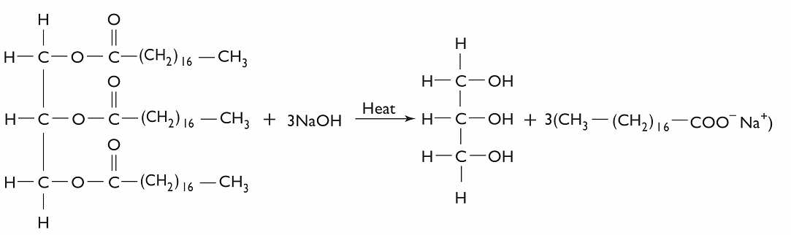

**Triglyceride** (fat) **🡪 glycerol + salt of fatty acid (soap)**

1. Determine the mass of one mole of the triglyceride molecule. (2 marks)

_______________________________________________________________________________

_____________________________________________________________________________________________________________________________________________________________________________________________________________________________________________

1. If 0.140 moles of triglyceride reacts, how many moles of the salt of a fatty acid are produced?

(3 marks)

_______________________________________________________________________________

____________________________________________________________________________________________________________________________________________________________________________________________________________________________________________________________________________________________________________________________

1. What is the mass of salt of fatty acid resulting from the breakdown of 0.140 moles triglyceride? (2 marks)

_______________________________________________________________________________

____________________________________________________________________________________________________________________________________________________________________________________________________________________________________________________________________________________________________________________________

1. Determine the percentage composition of each element in a triglyceride molecule.

(3 marks)

_______________________________________________________________________________

____________________________________________________________________________________________________________________________________________________________________________________________________________________________________________________________________________________________________________________________

_______________________________________________________________________________

____________________________________________________________________________________________________________________________________________________________________________________________________________________________________________________________________________________________________________________________

**Question 40 (10 marks)**

The study and assembly of materials at the subatomic level is otherwise known as **Nanotechnology**. This emerging area of Science is aiming to provide solutions to some of the problems that humanity faces.

(a) Describe two examples of nanotechnology potentially solving present day problems

(4 marks)

_______________________________________________________________________________

____________________________________________________________________________________________________________________________________________________________________________________________________________________________________________________________________________________________________________________________

_____________________________________________________________________________________________________________________________________________________________________________________________________________________________________________

____________________________________________________________________________________________________________________________________________________________________________________________________________________________________________________________________________________________________________________________

(b) Describe one potential risk arising from the use of nanotechnology. (2 marks)

_______________________________________________________________________________

_____________________________________________________________________________________________________________________________________________________________________________________________________________________________________________

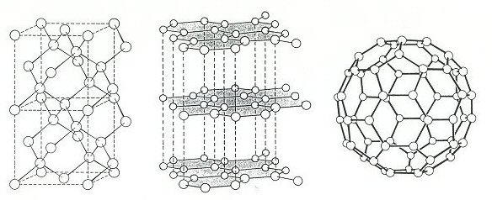

(c) Three allotropes of carbon (diamond, graphite and a fullerene) are shown above.

1. What do you understand by the term ‘allotrope’ (1 mark)

__________________________________________________________________________________________________________________________________________________

1. Account for one physical property of each allotrope with reference to the bonding type present. Your answer must include a different property for each. (3 marks)

_______________________________________________________________________________

____________________________________________________________________________________________________________________________________________________________________________________________________________________________________________________________________________________________________________________________

_______________________________________________________________________________

______________________________________________________________________________________________________________________________________________________________________________________________________________________________________________________________________________________________________________________________________________________________________________________________________________________________________________________________________________________________________________________________________________________________________________________________________________________________________________________________________________________________________________________________________________________________________________________________________________________

**Question 41 (10 marks)**

A typical diesel molecule has the molecular formula **C16H34**. It is produced by the fractional distillation of crude oil. Biodiesel, however, is derived from renewable sources such as vegetable oil or animal fat and has a typical molecular formula, **C17H34O2**.

The equations for the complete combustion for these 2 fuels are:

(i) 2 C16H34 (l) + 49 O2 (g) 32 CO2 (g) + 34 H2O (l)

(ii) 2 C17H34O2 (l) + 49 O2 (g) 34 CO2 (g) + 34 H2O (l)

1. In order to determine the mass of carbon dioxide released from the combustion of 1.000 tonne of C16H34 and 1.000 tonne of C17H34O2, first determine the number of moles of each reactant in 1.000 tonne. (4 marks)

(i)_____________________________________________________________________________________________________________________________________

______________________________________________________________________________________________________________________________________ (ii)__________________________________________________________________________________________________________________________________________________________________________________________________________________________________________________________________________

1. Determine the number of moles of carbon dioxide released from the combustion of 1.000 tonne of each diesel molecule. (2 marks)

(i)_____________________________________________________________________________________________________________________________________

______________________________________________________________________________________________________________________________________

(ii)_______________________________________________________________________________________________________________________________________________________________________________________________________

___________________________________________________________________

1. Assuming 3.50 tonnes of oxygen gas is available for each reaction determine whether there is sufficient oxygen for complete combustion. You must show all working for maximum marks.

(4 marks)

(i)_____________________________________________________________________________________________________________________________________

__________________________________________________________________________________________________________________________________________________________________________________________________________________________________________________________________________________________________________________________________________________________________________________________________________________

(ii)_________________________________________________________________________________________________________________________________________________________________________________________________________________________________________________________________________________________________________________________________________________________________________________________________________________________________________________________________________________________________________________________________________________________________________________________________________________________

**Question 42 (9 marks)**

Our current conception of the atomic model is due to a series of findings from key experiments in the past. Some involved newly developed devices of that time. Below are depictions of some of the devices or data obtained from the experiment. Outline how the principal findings of each contributed to our current understanding of atomic structure.

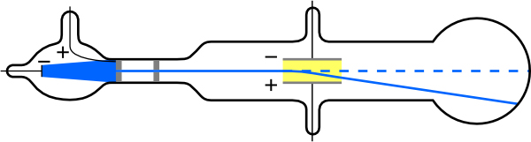

Cathode Ray Tube

______________________________________________________________________________________________________________________________________

____________________________________________________________________________________________________________________________________________________________________________________________________________________________________________________________________________

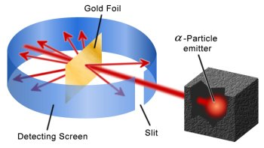

Rutherford’s Gold Foil Experiment

______________________________________________________________________________________________________________________________________

____________________________________________________________________________________________________________________________________________________________________________________________________________________________________________________________________________

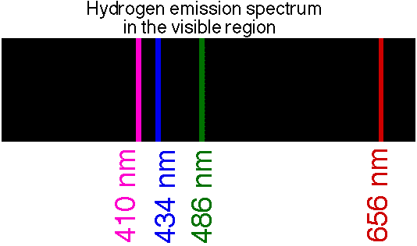

______________________________________________________________________________________________________________________________________

____________________________________________________________________________________________________________________________________________________________________________________________________________________________________________________________________________

END OF EXAMINATION